Meeting Minutes – Winnipeg Actuaries Club Semi-Annual Meeting

Location: Virtual Teams Meeting
Date: Thursday, June 17, 2021
Time: 1:00 PM – 2:30 PM

Attendance
Guests:
- Dr. Victor Cui, Associate Professor at Asper School of Business (panelist)
- Fiona So, Actuarial Advisor OSFI (panelist)
- Chris Fievoli (CIA representative)
- Ben Marshall (SOA representative)
- UMAC co-presidents and club members
Agenda
- Panelist Discussion
- Business meeting:
- Cody presents slide deck (above) of WAC activities over the last 6 months
- Call for Member at Large position. No names were put forward
- Poll 1: Interested in Logo Contest? Results: 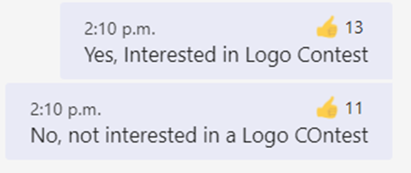
- Poll 2: Interested in participating in a Mentorship Programme? 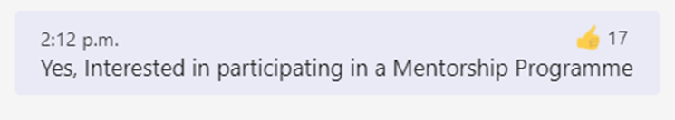
- Asks if there are any questions from Members. No questions were put forward.

